

# SCHOOL INFO

**Supervisor:** *Nguyễn Lê Xuyên*

**Semester:** *01*

**Batch No: T1.2401.E0**

**Group No:** *03*

|  |  |  |
| --- | --- | --- |
| **Order:** | **Full name** | **Roll No.** |
| *1.* | *Le Thanh Phu* | *Student1548611* |
| *2.* | *Truong Anh Duong* | *Student1545878* |
| *3.* | *Nguyen Hoan Nguyen* | *Student1545457* |
| *4.* | *Vu Minh Hoang* | *Student1545747* |

***Month****: 5* ***Year****: 2024*



This is to certify that

**Ms. Le Thanh Phu Ms. Truong Anh Duong Mr. Nguyen Hoan Nguyen**

**Ms. Vu Minh Hoang**

Have successfully Designed & Developed

SCHOOL INFO

Submitted by:

**Mr. Le Thanh Phu**

Date Of Issue:

17 - May - 2024

Authorized Signature:

**Mr. Le Thanh Phu**

**Content**

Content

Acknowledge

Synopsis

Problem Definition

Customer Requirements Specifications

Architecture and design of the project

1. Home
2. Home page
3. News page
4. Introduce some schools
5. All School page, Detail
6. School page
7. School page detail
8. About Us
9. About us
10. Contact
11. Log in
12. Contact for us
13. Responsive web
14. Laptop

**Acknowledge**

As we understand that the eProject is a step-by-step learning environment that closely simulates the classroom and Lab-based learning environment into actual implementation. It is a project implementation at your fingertips!! An electronic, live juncture on the machine that allows you to.

* Practice step by step i.e. laddered approach.
* Build a larger more robust application.
* Usage of certain utilities in applications designed by user.
* Single program to unified code leading to a complete application.
* Learn implementation of concepts in a phased manner.
* Enhance skills and add value.
* Work on real-life projects.

Give a real-life scenario and help to create applications that are more complicated and useful.

Mentoring through email support.

First of all, I would like to thank India Aptech for allowing my team to work on this fantastic eProject. We had a great experience with eProject this time.

Next, We would like to express my special thanks to our mentor, Ms. Ha Vy for the time and effort that she provided throughout the project. Your helpful advice and suggestions were beneficial to us during the completion of the project. In this respect, We are forever grateful to you.

Besides several mistakes we made in the project, we hope to have more opportunities to widen our knowledge in the web-developing world.

We will try to continue to learn and improve ourselves even more in the future.

Yours Sincerely, Team 03.

**Synopsis**

The Objective of this program we aim is to give a sample project to work on real- life projects. These applications help us build a larger more robust application.

The objective is not to teach us HTML/JavaScript but to provide us with a real-life scenario and help us create basic applications using the tools.

Hence, we can revise the chapters before we start with the project.

This project is meant for students like us who have completed the module of HTML5. These programs should be done in the Lab sessions with the assistance of the faculty if required.

The website (in this project) is a tool that brings everything in the world to you such as historic monuments information natural knowledge and skill in technology...

It is very essential for us that will have a clear understanding of the subject. We think we should go through the project and solve the assignments as per the requirements given.

And get back [***eprojects@aptech.ac.in***](mailto:eprojects@aptech.ac.in) as the assigned schedule.

**Problem Definition**

***Reviewedu.vn***- as a large admissions site that specializes in providing overall views; and the most accurate information about educational levels throughout Vietnam. Reviewedu admission channel focuses on information about Universities - Institutes, Colleges and Intermediate Schools. With the intention of night coming to the viewer; Students and parents have the most comprehensive and accurate views; about the quality of teaching and training, benchmarks, tuition, facilities... As well as issues surrounding schools.

**Requirement Specification:**

eProject Report should comprise-

qAcknowledgements

qeProject Synopsis

qeProject Analysis

qeProject Design

nDFD’s

nFlowCharts

nProcess Diagrams

nDatabase Design / Structure

qScreen Shot’s

qSource Code with Comments

qUser Guide

qDeveloper’s Guide

nModule Descriptions

User Guide means User Manual, it should have details how a user can operate the application.

Developer’s Guide should have detail description of the modules, so that any developer can look into the code and get to know about it through the Developer’s Guide.

Some of the benefits of eProject are as under: -

1. Re-enforcement of Skills happens in the experiential learning process.

2. A mentor, ensuring that you do not get drifted, constantly guides you.

3. It gives you a lot of confidence to face an interview as you have worked on a project. You can explain virtually everything on the subject you have learnt.

4. A nice, final, black, hardbound report adds to you credentials and enhances your job prospects.

eProjects is compulsory (Sem-End Project) and is supposed to be done over and above the assignments given in your course books.

It is advised that if a student follows the projects and submits assignments he would definitely have an edge over other students.

Students need to submit their project report along with working application and source code in the stipulated time.

Projects will be evaluated.

**Architecture and design of the project**

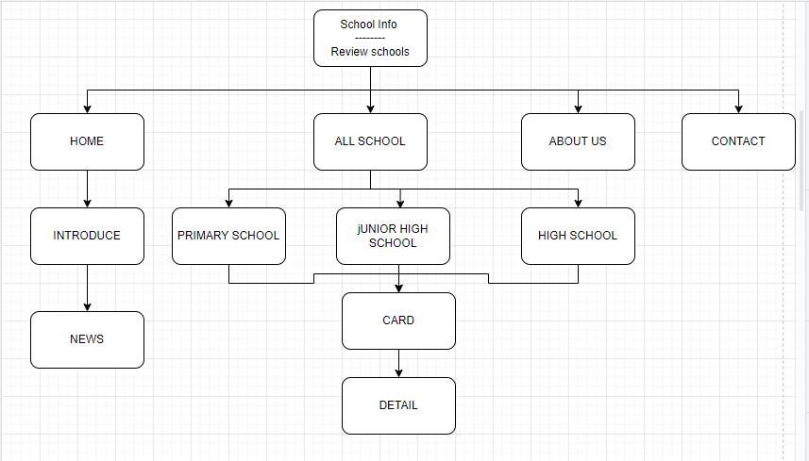

1. **Home**
2. **Home Page**

The home page is used to view a list of schools, levels and news about school-related issues

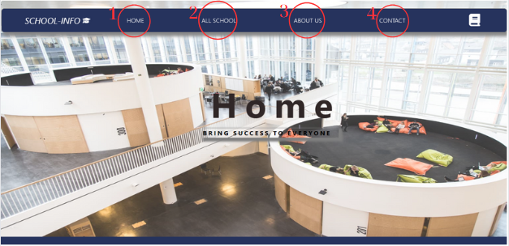

|  |  |  |  |
| --- | --- | --- | --- |
| **No** | **Type** | **Validation** | **Action** |
| 1 | Click |  | Navigation to Home page |
| 2 | Click |  | Navigate to the ALL SCHOOL page |
| 3 | Click |  | Navigation to About Us page |
| 4 | Click |  | Navigation to Contact page |

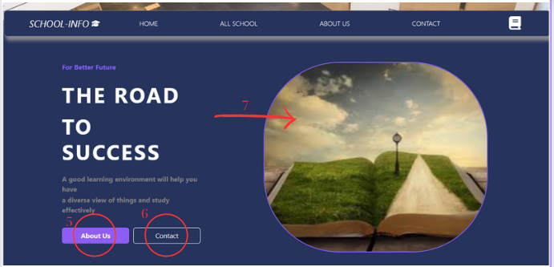

|  |  |  |
| --- | --- | --- |
| **No** | **Type** | **Action** |
| 5 | Click | Navigation to About Ús page |
| 6 | Click | Navigation Contact page |
| 7 | Hover | Zoom the image then blur |

1. **News page**

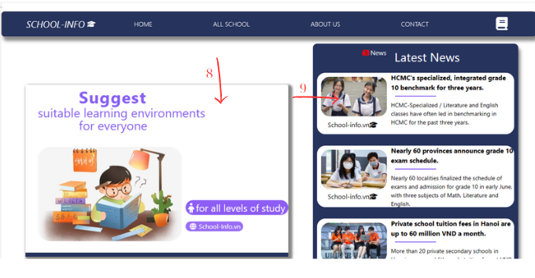

|  |  |  |
| --- | --- | --- |
| **No** | **Type** | **Action** |
| 8 | Hover | Porch overlay layer decorates the site |
| 9 | Hover | Blur the card |

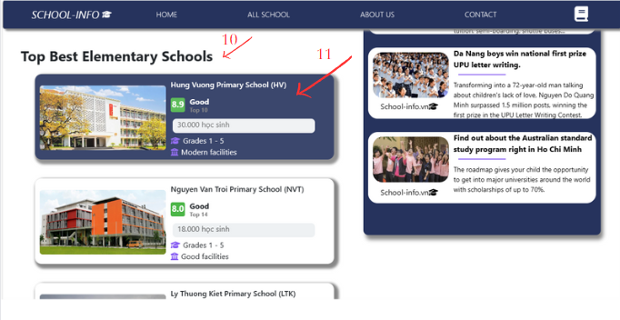

|  |  |  |
| --- | --- | --- |
| **No** | **Type** | **Action** |
| 10 |  | Introduction to primary school |
| 11 | Hover | Hover to change background color and decoration |

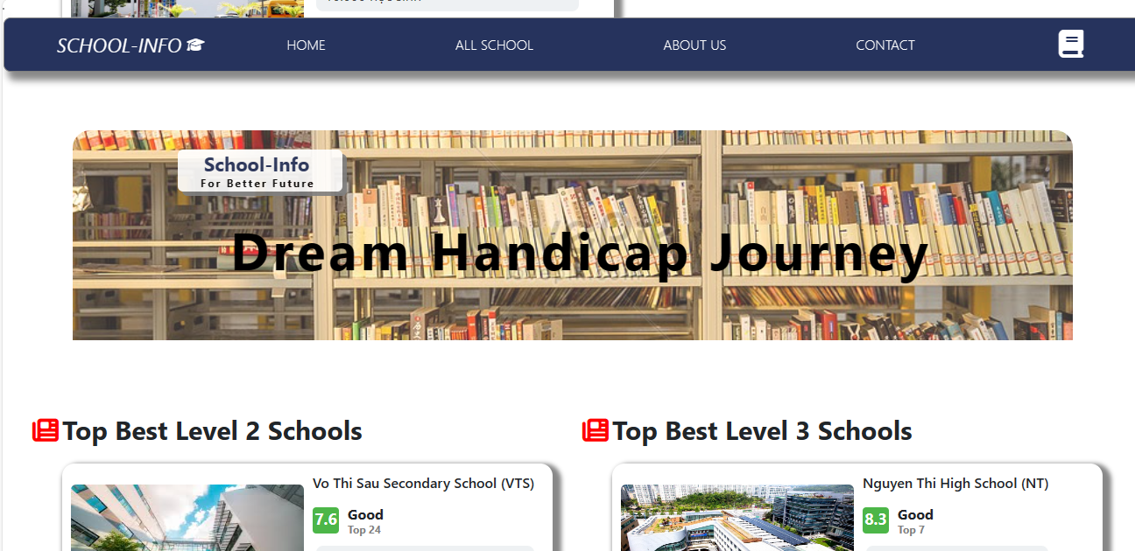

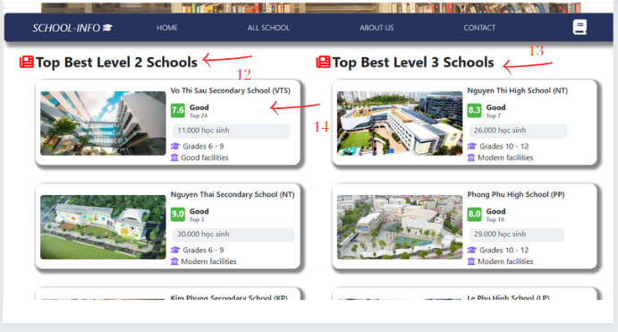

|  |  |  |
| --- | --- | --- |
| **No** | **Type** | **Action** |
| 12 |  | Introduction junior high school |
| 13 |  | Introduction high school |
| 14 | Hover | Hover to change background color and decoration |



**II, All school page, Detail**

**1. School page**

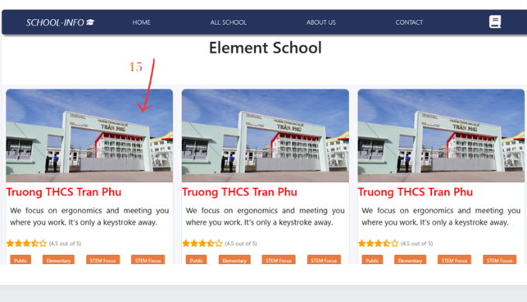

|  |  |  |
| --- | --- | --- |
| **No** | **Type** | **Action** |
| 15 | Click | Navigate to the details page |

1. **Detail page**

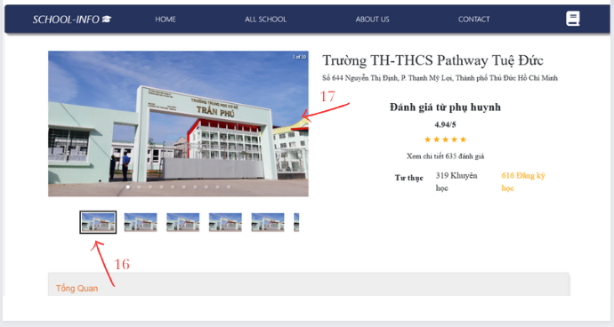

|  |  |  |
| --- | --- | --- |
| **No** | **Type** | **Action** |
| **16** |  | **Move forward by clicking number 17** |
| 17 | Click | Image transfer |

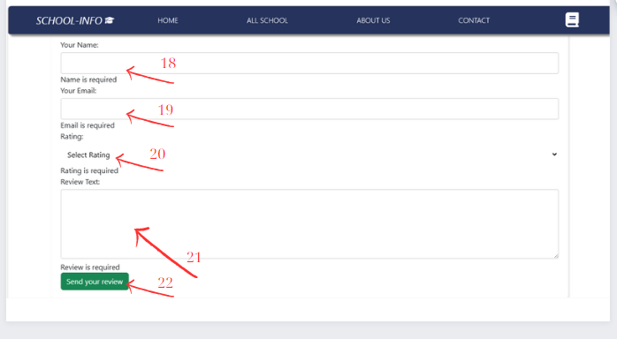

|  |  |  |
| --- | --- | --- |
| **No** | **Type** | **Action** |
| 18,19,20,21 | Text | If left blank, it will say ''required'' |
| 19 | Text | If you enter the wrong email form, an error message will be reported |
| 22 | Click | To submit and will report an error if the above boxes have incorrect syntax as above |

1. **About Us**

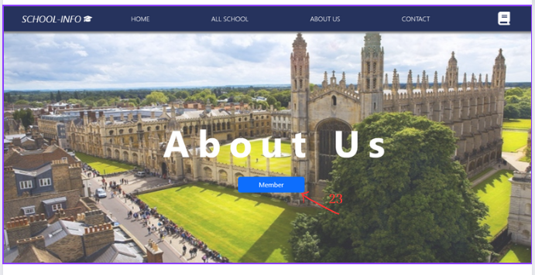

|  |  |  |
| --- | --- | --- |
| **No** | **Type** | **Action** |
| 23 | Click | Clicking will take you to the members section |

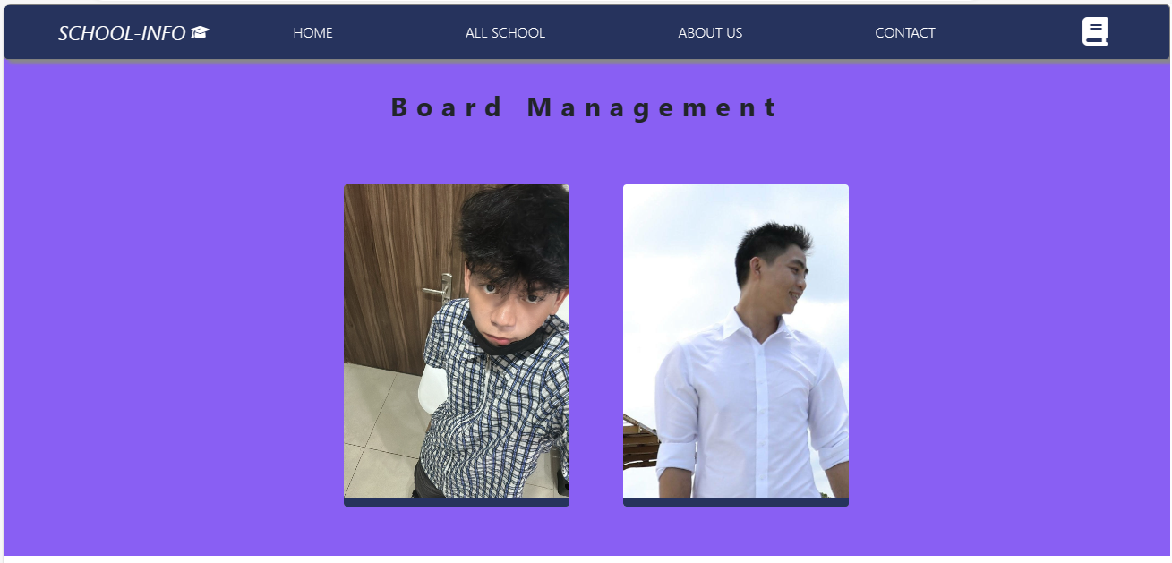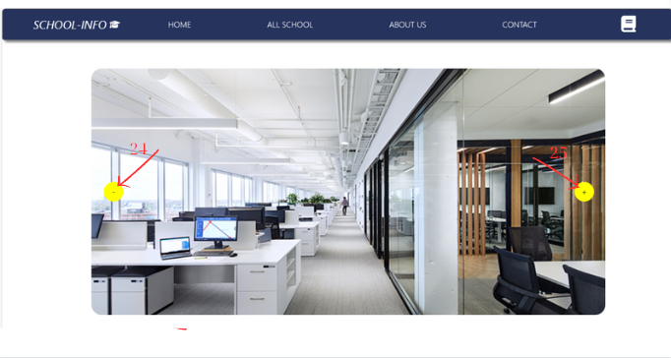

|  |  |  |
| --- | --- | --- |
| **No** | **Type** | **Action** |
| 24 | Click | Click to move to the next photo |
| 25 | Click | Click to switch to the previous photo |

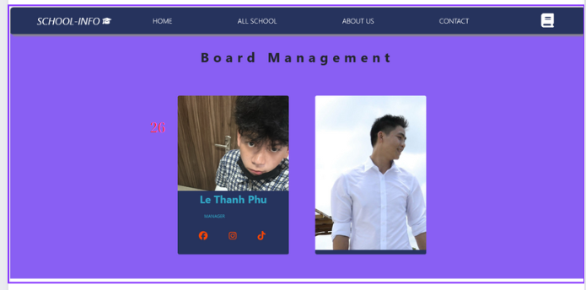

|  |  |  |
| --- | --- | --- |
| **No** | **Type** | **Action** |
| 26 | Hover | Hovering on the image will display an overlay layer introducing member information with a transition effect |

1. **Contact**

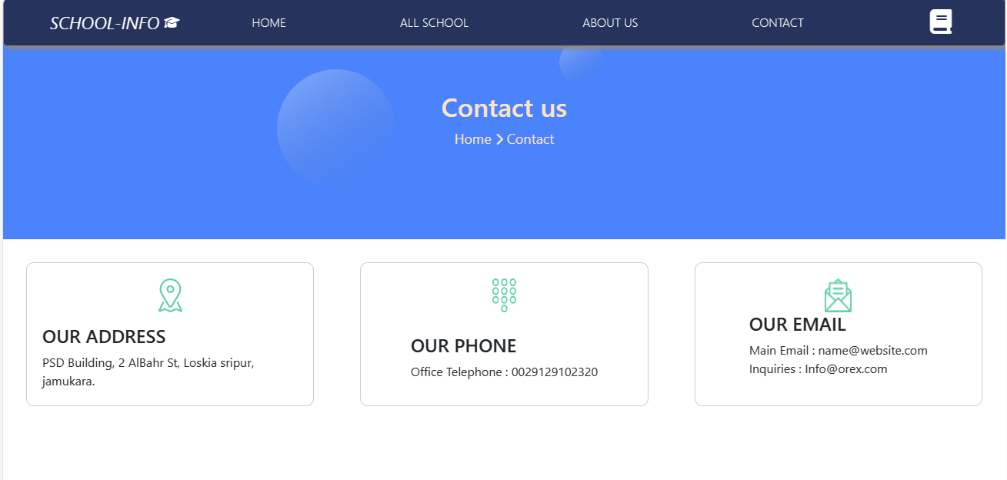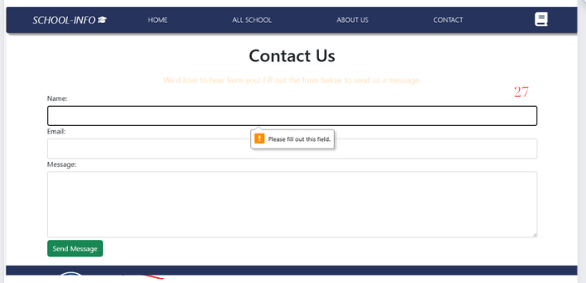

|  |  |  |
| --- | --- | --- |
| **No** | **Type** | **Action** |
| 27 | Text | If left blank, it will say ''required'' |

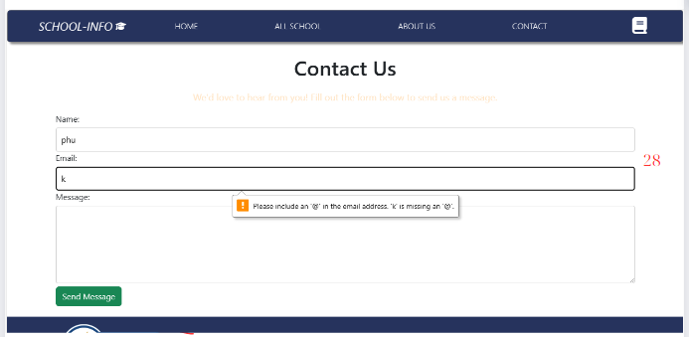

|  |  |  |
| --- | --- | --- |
| **No** | **Type** | **Action** |
| 28 | Text | If you enter the wrong email form, an error message will be reported |

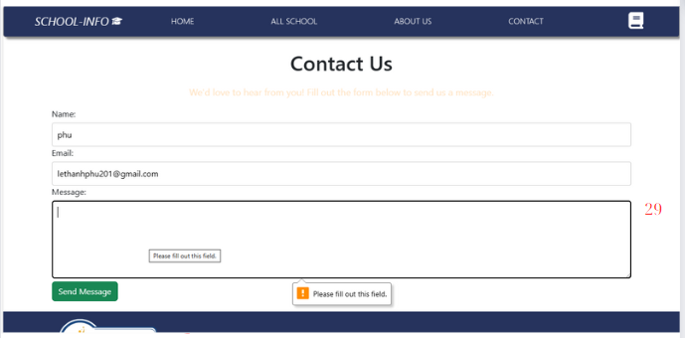

|  |  |  |
| --- | --- | --- |
| **No** | **Type** | **Action** |
| 29 | Text | If left blank, it will say ''required'' |

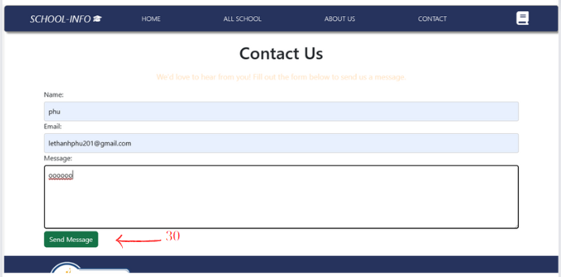

|  |  |  |
| --- | --- | --- |
| **No** | **Type** | **Action** |
| 30 | Text | To send and will report an error if the above cells have incorrect syntax as above and when sent successfully, that information will be deleted. |

**Task Sheet**

|  |  |  |  |  |  |  |  |
| --- | --- | --- | --- | --- | --- | --- | --- |
| **No** | **Member** | **Page Name** | | **Planed Start Date** | **Actual Start Date** | **Actual End Date** | **Status** |
| *1.* | **Lê Thanh Phú** | **Home**  Introduce-News-Card | | 14/04/2024 | 15/04/2024 | 10/05/2024 | **100%** |
| **About Us** | | 14/04/2024 | 15/04/2024 | 10/05/2024 | **100%** |
|
|
|
| *2.* | **Trương Ánh Dương** | **All School** | | 14/04/2024 | 15/04/2024 | 10/05/2024 | **100%** |
| **Detail-All School** | | 14/04/2024 | 15/04/2024 | 10/05/2024 | **100%** |
| **Contact** | | 14/04/2024 | 15/04/2024 | 10/05/2024 | **100%** |
|
|
|
|
|
| *3.* | *Vũ Minh Hoàng* | **0%** |
|
|
|
| *4.* | *Nguyễn Hoàn Nguyên* | **0%** |